San Francisco Pays $16.1 Million to Shelter 300 Homeless in Tents

BY [**RICK MORAN**](https://pjmedia.com/columnist/rick-moran) MAR 05, 2021 10:08 AM ET

*(AP Photo/Marcio Jose Sanchez, File)*

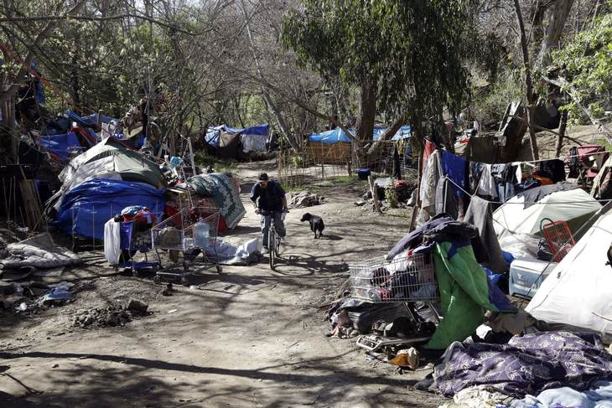

California is in the midst of a self-induced homelessness crisis that shows no sign of abating anytime soon. The crisis is especially acute in San Francisco, where Mayor London Breed has erected three tent cities to house about 300 homeless people.

The cost? About $61,000 a year per tent. All told, the cost of the program is $16.1 million. I guess in San Francisco, even the tents are first class.

The city is running a $650 million deficit and the tent city isn’t eligible for reimbursement by the government, so that money comes out of city coffers. If the homeless were housed in a first-class hotel, the federal government would gladly reimburse the city for that, but not for a few measly tents?

In the six “Safe Sleeping Villages” set up by the city of San Francisco during the pandemic, the cost of maintaining a single tent-camping spot is $5,000 per month, or $61,000 per year — more than it would cost to put each of these people in a market-rate apartment.

The insane costs of running these sleeping “villages,” which only have space for a total of 262 tents spread across the six sites, makes one immediately think of the criticisms that are leveled against the Homeless Industrial Complex, as conservative commentators are eager to call it. The revelation of the price tag for the tent program — $16.1 million for the year — came at a budget committee meeting on Wednesday, as the Chronicle reports, via Abigail Stewart-Kahn, the interim director of the Department of Homelessness and Supportive Housing. In addition to the tents, the city supplies meals, sanitation services, and police protection.

The cost boils down to $190 per tent per night, which includes 24-hour security, bathrooms, maintenance, and three meals per day. This is cheaper than the per-day cost for the hotel program, but the hotel program is getting [100% federal reimbursement](https://sfist.com/2021/03/03/with-fema-funding-assured-sf-supervisors-approve-400-more-hotel-rooms-for-homeless/). (Thanks, Biden.)

Also, the Department of Homelessness and Supportive Housing has committed to re-housing everyone as the [sic] come out of the hotel rooms — an enormous task, given that there are upwards of 2,000 people currently in the program.

San Francisco counts about 6,400 people as homeless, although that doesn’t include people living out of their cars, or the thousands who flit from temporary shelters to relative’s residences to friends and neighbors — anywhere they can find a place to lay their body down. Many of these people have jobs that don’t pay them enough to live within 50 miles of San Francisco.

The city was basically forced to adopt the tent idea because most homeless shelters closed down due to COVID restrictions. But $5,000 a tent? Certainly, allowances should be made but that is a ludicrous amount of money to spend on any group, regardless of their hard-luck circumstances.

Even city council members are critical. “I understand the motivation to create sleeping space during this COVID-19 crisis,” says Supervisor Ahsha Safaí, speaking to [the *Chronicle*](https://www.sfchronicle.com/local/article/S-F-pays-61-000-a-year-for-one-tent-to-house-16001074.php). “But we really need to dive deep to see if this is a sustainable model… without any federal reimbursement.”

Perhaps if they had “dove deep” before they wasted this money, they wouldn’t be regretting it now.